Name: Celebrate

Surname: Mashaba

Student number: ST10055395

Module name: System Analysis and Design

Module code: SAND6211

Assessment type: Assignment

Group 1

Question 1

The System Development Life Cycle (SDLC) is a process used by software Development teams to design, develop, and maintain software. The SDLC is a framework for organizing and controlling the entire software development process, from project planning to development and maintenance. The SDLC consists of several core processes, each with its own set of activities, deliverables, and quality gates. These core processes include:

Planning

-The planning process involves defining the scope of the project, identifying stakeholders, and establishing project objectives. It is critical to set realistic goals for the project, establish a budget, and create a timeline for the project. Without proper planning, the project may fail due to unrealistic expectation or lack of funding.

Analysis

-The analysis process involves gathering and analyzing information about the requirement for the software. This include defining functional and non-functional requirements, identifying constraints and risks, and understanding the user’s needs. Failure to analyze requirement properly can lead to a product that does not meet the user’s needs or has security vulnerabilities.

Design

-The design process involves creating a detailed plan for the software. This includes designing the software architecture, data model, user interface, and system interfaces. A poorly designed system may be difficult to use or may be vulnerable to attacks.

Implementation

-The implementation process involves developing the software, coding, and testing. This process requires adherence to coding standards, testing, and debugging. Failure to properly implement the software can lead to crashes or other errors.

Testing

-The testing process involves verifying that the software meets the functional and non-functional requirement. This include testing for usability, performance, security, and compatibility. Failure to test the software can lead to bugs, security vulnerabilities, or other issues that can negatively impact that user experience.

Each core process of the SDLC is important and contributes to the success of the project. Neglecting any these processes can lead to a poorly designed and implemented product that does not meet the user’s needs or is vulnerable to security breaches.

Available at: <https://www.sciencedirect.com/topic/computer-science/system-development-life-cycle>

[Accessed 17 April 2023]

Question 2

2.1 The project of creating a trip booking system for elders may have a variety of stakeholders, each with a different level of interest and contribution to the requirement definition:

Elders

-These are the primary users of the system, and their needs and preferences will guide the requirement definition. Elders can provide insight into their requirement and expectations from the system in terms of accessibility, ease of use, and security

Caregivers

-caregivers can provide valuable insights into the specific requirement of the elderly population in terms of their mobility, medical needs, and other aspects that may affect that may affect their travel arrangement. They can also help define the requirements for the caregiver support, such as the need for assistance in booking and managing

Trip coordinators

-trip coordinators can provide insights into the requirement for managing and coordinating trip, and accommodation. They can also provide insight into the needs of the elder population in terms of accessibility, safety and comfort

Payment processors

-payment processors are stakeholders in the system because they will be responsible for processing the financial transaction involved in booking trips. They can provide insight into the requirement for secure and reliable payment processing, such as the for encryption, fraud prevention, and data protection

System administrators

-system administrators are responsible for managing and maintaining the trip booking system. They can provide insights into the requirement for system security, data privacy, and system performance

Regulators and policymakers

-regulators and policymakers can provide insight into the legal and regulatory requirement that the trip booking system must meet. They can also provide insight into the polices and guidelines that must be followed in terms of data privacy, security, and accessibility

Available at: <https://www.sciencedirect.com/topic/computer-science/stakeholder-project>

[Accessed 17 April 2023]

2.2 User-friendly interface

-A simple and easy-to-use interface is essential for any application to be successful. Users should be able to navigate through the application easily and find what they need without difficulty

Customization

-Users should be able to customize the application to suit their specific needs. This may include the ability to choose specific features or functionalities, adjust setting, or personalize the user interface

Robust and Reliable Functionality

-The application should function smoothly and without errors, even when handling large volumes of data. It should also be able to handle complex operation and calculation, and provide accurate results

Security

-The application should have strong security feature to protect user data, including encryption, user authentication, and access control. It should also be regularly tested and update to ensure it is protected against new security threats

Integration with other application

-Users may require integration with other application or system, such as APIs or other data source. The application should be able to integrate easily with other system and provide seamless data exchange between them.

Available at: <https://www.science.com/topic/computer-science/desgin-development-effort>

[Accessed 17 April 2023]

2.3 –User authentication and authorization system to ensure only authorized users can access the application

-Trip booking system to enable users to book trips and manage their booking

-Payment gateway integration to allow users to make payments for their booking

Available at: <https://www.sciencedirect.com/topic/computer-science/user-goal-technique>

[Accessed 17 April 2023]

2.4

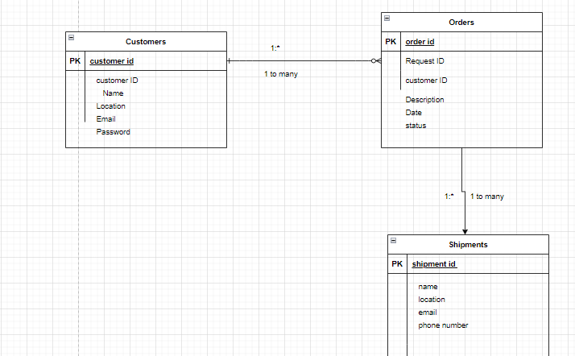

Available at: <https://www.sciencedirect.com/topic/computer-science/entity-relationship-diagram>

[Accessed 17 April 2023]

2.5 <https://www.edrawmax.com/online/share.html?code=ffa44324e8e411ed8eba0a54be41f961>

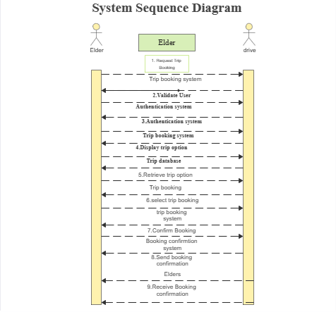

Available at: <https://www.sciencedirect.com/topic/computer-science/System-sequence-diagram>

[Accessed 17 April 2023]

Question 3

Authentication and Authorization:

One of the most basic steps in securing an application is to ensure that only authorized users can access it. Authentication mechanisms such as passwords, two-factor authentication, biometrics, and other forms of identification help to verify the identity of the user. Authorization controls determine what actions each user can perform within the application

Available at: <https://www.sciencedirect.com/topic/computer-science>

[Accessed 17 April 2023]

Question 4

4.1 – Responding to change over following a project plan

-Customer collaboration over agreement negotiation

-Working software over comprehensive documentation

-individuals and interactions over procedures and devices

Available at: <https://www.science.com/topic/computer-science/agile-development>

[Accessed 17 April 2023]

4.2 PRESENTATION



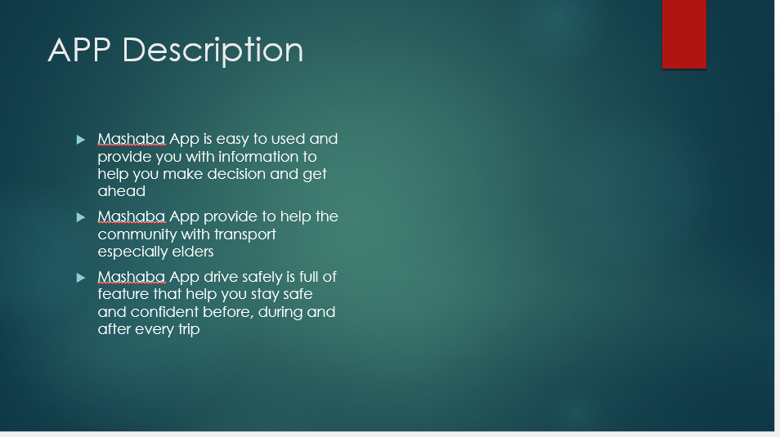

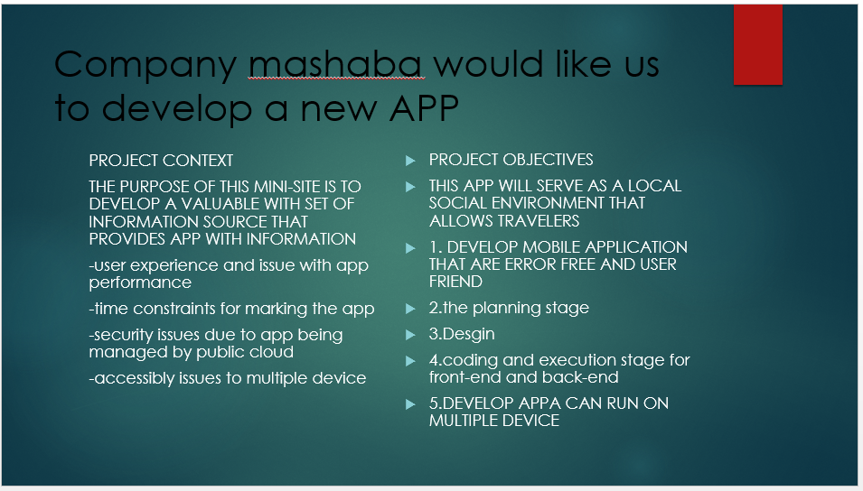





Available at: <https://www.science.com/topic/computer-science/PRESENTATION>

[Accessed 17 April 2023]